EXPERIMENT 1 A
SETTING UP PYTHON ENVIRONMENT AND LIBRARIES –
JUPYTER NOTEBOOK

AIM:
To install Python, configure Jupyter Notebook, understand the notebook environment, execute Python programs, create Markdown cells, and use basic Jupyter Notebook features for Data Analytics applications.

ALGORITHM 1 :
Step 1: Download Python from python.org Step 2: Run the installer
Step 3: Select "Add Python to PATH" Step 4: Click Install Now
Step 5: Verify installation using: python --version
Step 6: Observe installed Python version.

PROGRAM 1 :
Simple Python Program
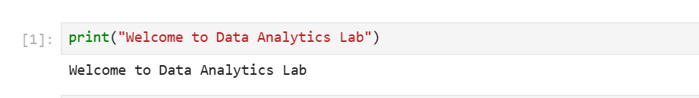
PROGRAM 2:
Arithmetic Operations
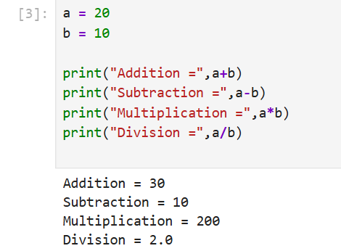
PROGRAM 3:
Display Student Details
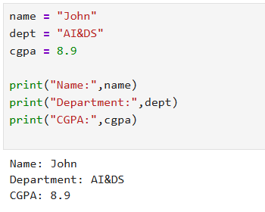

PROGRAM 4:
Using NumPy Library
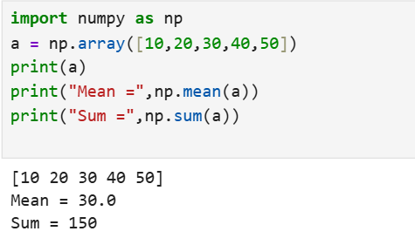

PROGRAM 5:
Using Pandas Library
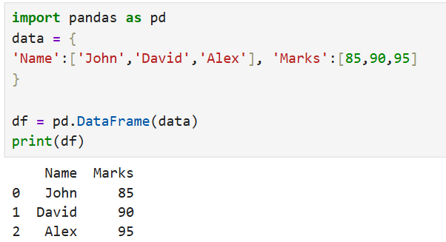

PROGRAM 6:
Data Visualization
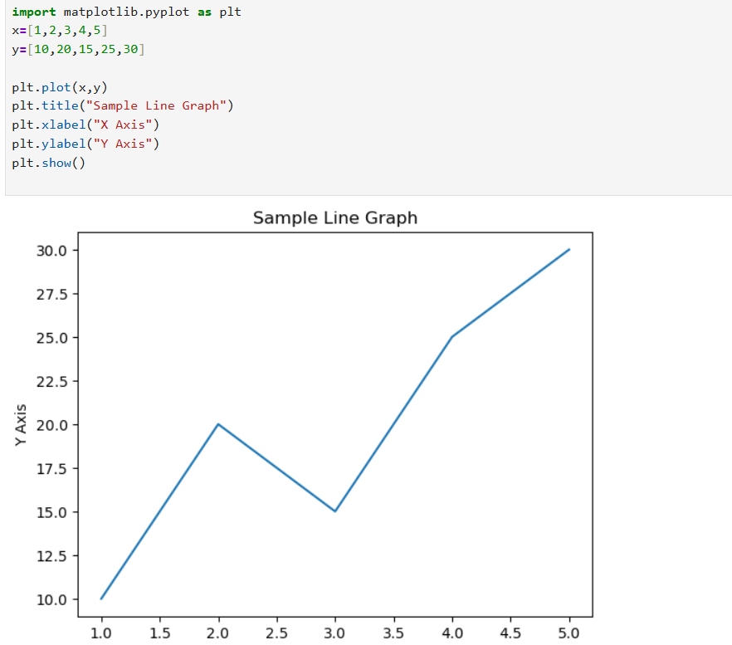

Result:
Successfully installed Python, configured Jupyter Notebook, understood the notebook environment, executed Python programs, created Markdown cells, and used basic Jupyter Notebook features for Data Analytics applications.

